# DESCRIPTION OF SITE DESIGN

With this the design of our website, there was a few decisions and changes we had to go through before arriving to what we finally have. We started with what way to structure the page, as there are three of us in a group there was a few ideas that we had to go through, until finally arriving at what we have.

To what the structure of the page should look like, we had to discuss what size of fonts was to be used, what images were well suited, what way or side should the floating of the texts be on in other to make finally arrive to what we have now, we practically tried it all.

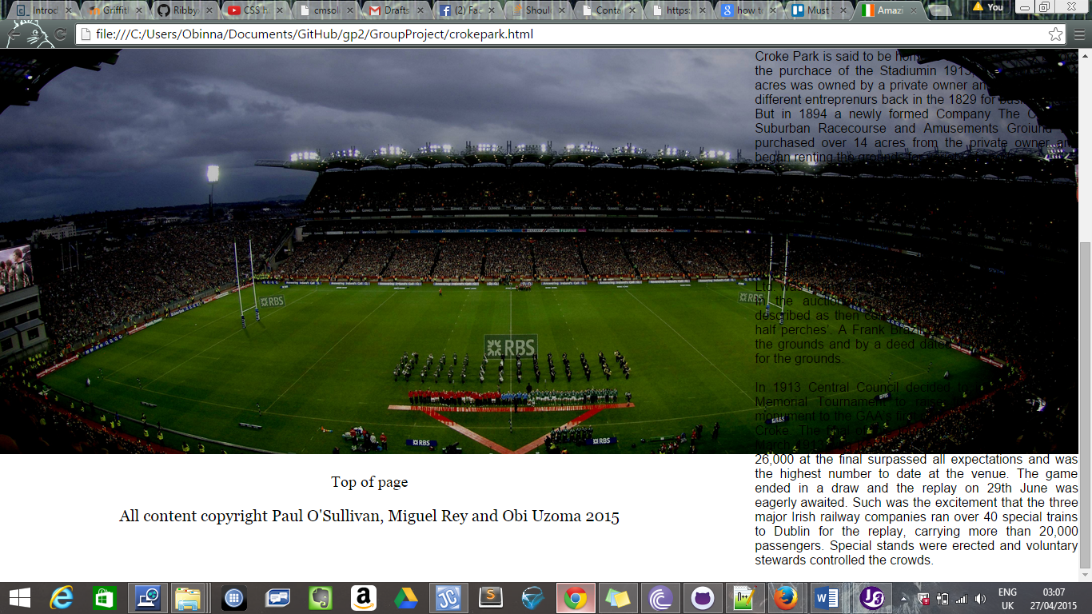

The above print screen image is showing the decision of using either the right float on the site or just taking of the float and setting the margin to auto, allowing the texts to be aligned to the centre as such below.

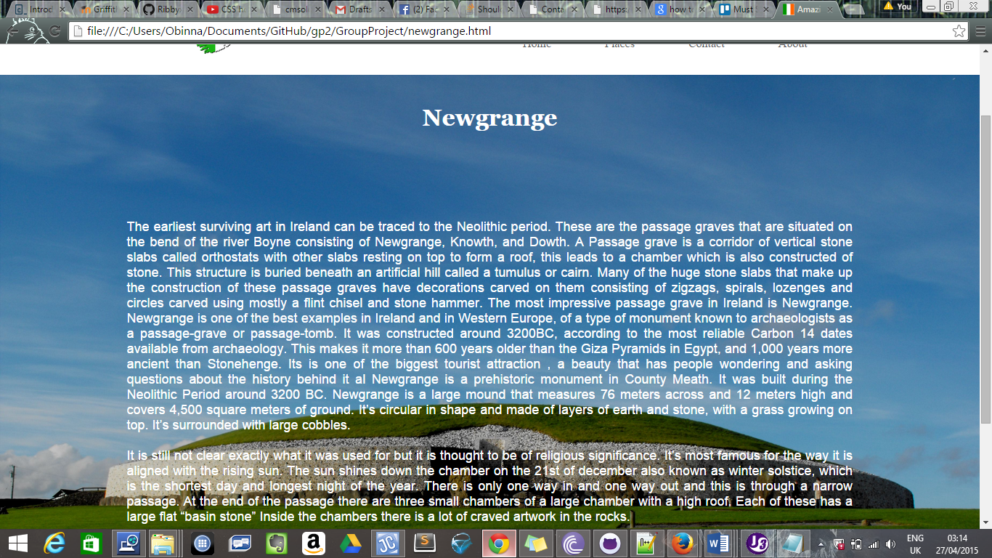

We then moved on to researching each tourist attraction, but in other to make this a well organised project, in a way that each of us knew what tasks to carry out, for this to have been done, we created tasks on Trello, a system that was used to assign tasks to everyone. With Trello we had a *To-Do*, *In-Progress*, *Testing*, and *Done* lists.

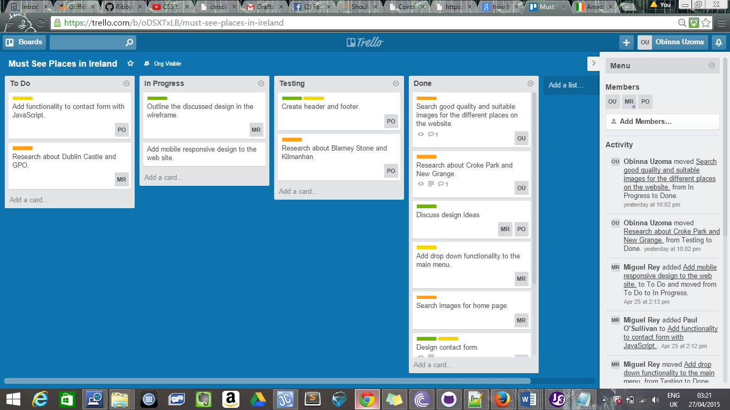Under the To-Do list was that the tasks each one us has to carry out, so when we began our research we are to drag our list into *In-Progress* thereby alerting our fellow team mates that we are currently working on a particular topic, the it can be passed into the Testing list as the name goes when testing a line of code to see if it truly works, and if so then its passed to *Done*, again all to alert the team members that the part of the research is been completed. We then looked at how to make our site mobile using Css, JQuery and JavaScript, we also had make sure that each line of codes worked as we expected, although it wasn’t as easy as we thought, because for each that time a class was created on Css it somehow affected the rest of the pages or when trying to get the mobile part of it to work was becoming a hassle with the JavaScript throwing up errors. We also came across problems with committing our tasks on GitHub or corrections but again at the end of it all it was a success.